BLOG 1: ISOTONIC SPORTS DRINK






Water is the best way to rehydrate in short workouts, but if you’re doing anything over an hour, you need to think about refuelling. Carbohydrates are the main energy source in your diet. There are different types, but it’s sugar that you’ll use to get that quick hit of energy. There’s a lot on the news at the moment about the fact that we eat and drink too much sugar. Generally that’s true, but a small amount can be really useful when you’re running. There are lots of different options for getting the carbs in, and you do need to work out what’s best for you. Some people like sports gels, others like Jaffa cakes, jelly babies or even Percy Pigs! Sports drinks can be really useful because they don’t just give you the sugar you need, but also have the fluid to rehydrate you. You can buy isotonic drinks, but actually it’s really easy (and much cheaper!) to make your own. And there are only two or three ingredients!

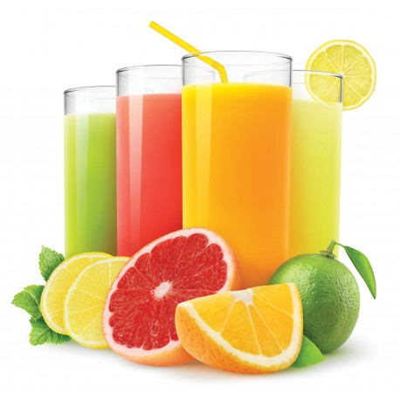
The first thing you’ll need is a fruit juice. Isotonic drinks basically mean that they have the same salt and sugar concentrations as your body, so that the salts and water you lose in sweat, and sugars can be easily absorbed. So you’ll need to do a bit of label reading and maths to get the concentration right. What you need to end up with is a drink that has the right concentration of sugar to make it isotonic.

Some drinks will have traffic light labels on them, usually on the front. It isn’t a legal requirement so not all drinks do. These can be a bit difficult to understand though because they don’t always talk about the same portion size.


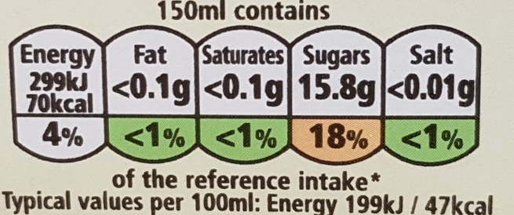

Traffic light labels have lots of different designs, and aren’t always included on drinks.

But it’s a legal requirement to put somewhere on the drink how much sugar there is in 100ml. It’s usually on the back, but could be on the side or front. Check the bottle and you should see something like the table below. You’ll need this to find out how much sugar the drink has.
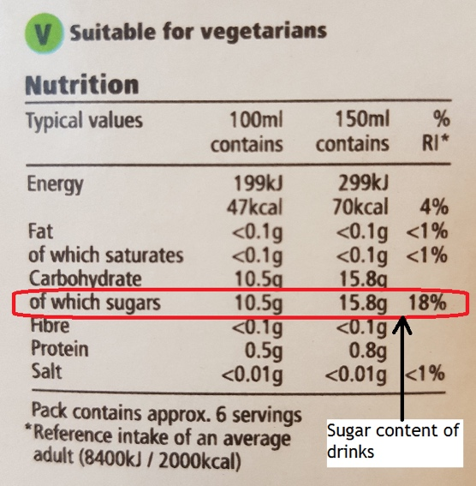

How to find out how much sugar there is in your drink

Because of the recent sugar tax, a lot of drinks now contain much lower levels of sugar than they used to. Great for the general public, but less so for runners! So you might need to check a few drinks until you find the right one.

Two drinks can actually have drastically different sugar contents.
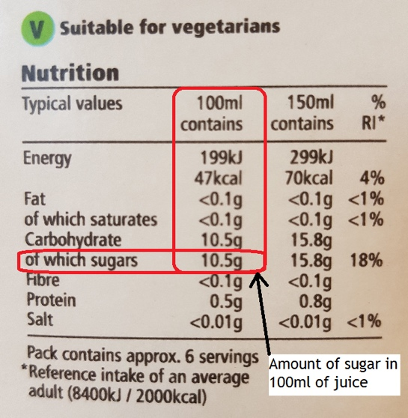
This is where it gets a bit more complicated. The label should show you how much sugar it has in 100ml, but might also show you how much there is in a portion.

You need to use the amount of sugar in 100ml to work out how much you need to dilute it to make it isotonic (i.e. has 4 to 8g of sugar in 100ml). So for example, the fruit juice below needs to be diluted 1 part juice to one part water.

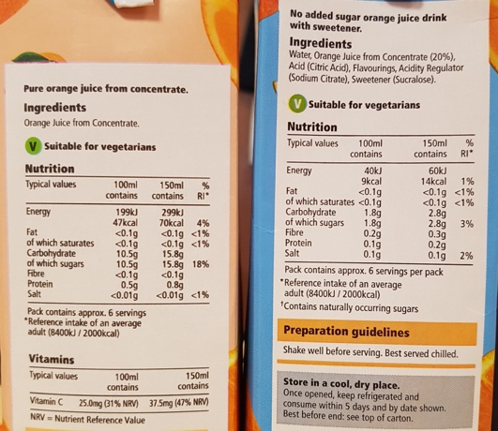
All you need to do now is to add some salt to replace the sodium you lose when you sweat. If it’s not particularly hot, or you’re training for less than 2 hours, you can skip this. But otherwise you’ll need to add ¼ to ½ teaspoon per litre of water.

And there you have it. An isotonic sports drink for a fraction of the price!

